Clinical Trials Object Data System (CTODS) Lab Viewer 1.0

caXchange – ScenPro, Inc.

End User Guide

DOCUMENT CHANGE HISTORY
Version Number | Date | Contributor | Description
1.0 | 1/09/2008 | Michael Holck | Initial Draft
1.1 | 2/18/2008 | Michael Holck | Added Hotlinks sections


Updated January 09, 2008

Contact Information
Contacts and Support
NCICB Application Support | http://ncicb.nci.nih.gov/NCICB/support  Telephone: 301-451-4384  Toll free: 888-478-4423

LISTSERV Facilities Pertinent to software teams
LISTSERV | URL | Name
CABIG_CTMS-L | https://list.nih.gov/archives/cabig_ctms-l.html | caBIG Clinical Trials Management System List
CABIG_CTMS_COND_SIG | https://list.nih.gov/archives/cabig_ctms_cond_sig.html | CTMS Study Conduct SIG List

TABLE OF CONTENTS
Background/Summary 1
Introduction 2
Overview 2
Dependencies 2
Security 2
Application Operation Steps 3
Login 3
Search for trial(s) 5
Successful Search Operation 5
Unsuccessful Search Operation 8
Load results to CTMS 9
Use Hyperlinks 11
Log Out 12
Hot Linking from caAERS 13
Hot Linking from PSC 15

Background/Summary
The Clinical Trials Object Data System (CTODS) Lab Viewer is a web based application developed by leveraging the SDK generated APIs of the CTODS Lab Domain UML model. In the original caXchange v 0.5, laboratory data from a cancer center was being transformed, routed, and persisted into the CTOM database, but there was no visual and user friendly GUI tool to view the laboratory data that got stored there. Based on the use cases identified by the SMEs of the CTMS Interoperability project, a new requirement was identified that made the viewing of lab data from CTODS an important piece of the CTMS interoperability project.
The CTODS Lab Viewer allows users to view laboratory activities records that are stored in the CTODS Lab Domain database. Users will be allowed to search the laboratory activity records by Patient Id, Study Id, Lab Start Date, and Lab End Date. When the search results are displayed, numeric results that are outside the high and low reference ranges of the lab tests will be highlighted to alert the user. This visual alert/trigger will allow the user to focus in and act on those specific lab test results.
Additionally, the CTODS Lab Viewer will allow users to send lab data in the form of XML messages via caXchange. The message that can be sent is a Load Lab Data message to the local CDMS application (C3D) application. CTODS Lab Viewer interface allows the user select which labs should be loaded into the CDMS.

Introduction

Overview
This user guide identifies and describes the general features and functionality as provided and displayed by CTODS Lab Viewer version 1.0. This document has been published to support the use of CTODS Lab Viewer by authorized users.
The CTODS Lab Viewer user interface driven capabilities are described by this document in the context of a linear use case (i.e. gain access, locate desired record, and execute desired action). It should be noted that a user may deviate or repeat interface actions as necessary as the path or option is made available by the interface. This user guide uses graphic elements (i.e. arrows, shapes, callouts, and text boxes) to note and explain functionality. The graphic elements are not represented on CTODS Lab Viewer actual interface. The user is responsible to make the distinction between a graphic element used to extenuate an instructional point and CTODS Lab Viewer interface objects.
The CTODS Lab Viewer documentation can be accessed at: https://gforge.nci.nih.gov/plugins/scmcvs/cvsweb.php/caxchange/?cvsroot=caxchange

Dependencies
The assumptions and dependencies to support the use of CTODS Lab Viewer by a user include:
- The CTODS is available for use on an authorized system/network
- Current system security protocols are in place and operational
- The user has access and authorization to use CTODS Lab Viewer

Security
CTODS Lab Viewer accesses, displays, and brokers sensitive individually identifiable patient health information. It is the user’s responsibility to ensure that CTODS Lab Viewer is used appropriately, to include:
- Exclusively limit the viewing of patient information to authorized personnel only
- Patient information shall not be released in any form to anyone not directly authorized to view and use the information
- Patient information will only be searched and displayed for purposes directly related to NCI officially sanctioned tasks and purposes
- The user shall log out and close the browser at the conclusion of the session
- The user shall not provide another with their unique user ID and password

Application Operation Steps

Login
- Insert and execute CTODS Lab Viewer URL using a compatible web browser.
- The ‘Central Authentication Service (CAS)’ applications access page will display.
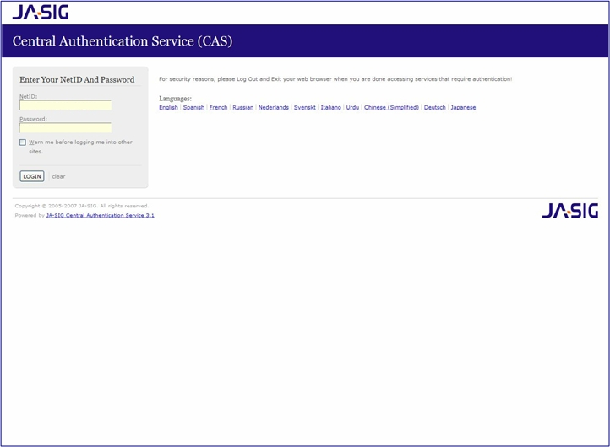
- Enter your user ‘NetID’ and ‘Password’ in the fields of the same name.
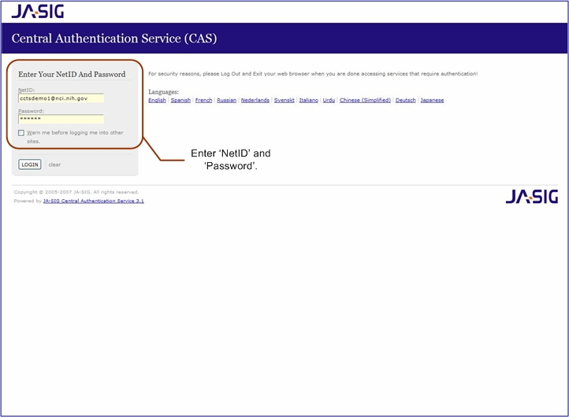
- Select the ‘LOGIN’ button to access CTODS Lab Viewer.
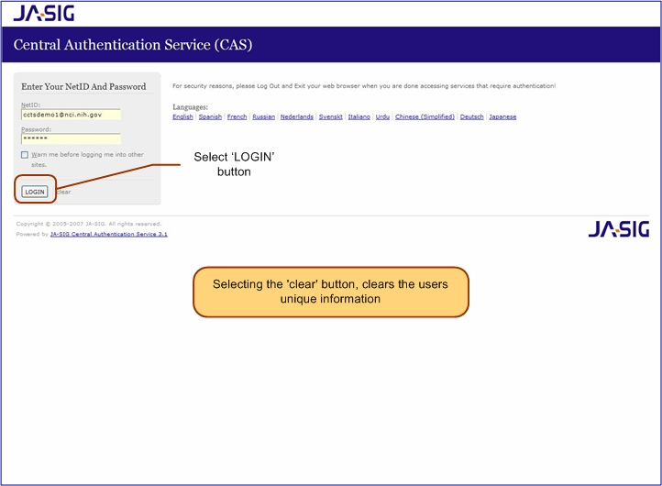
- The CTODS Lab Viewer ‘Home’ page with ‘Welcome’ will display.
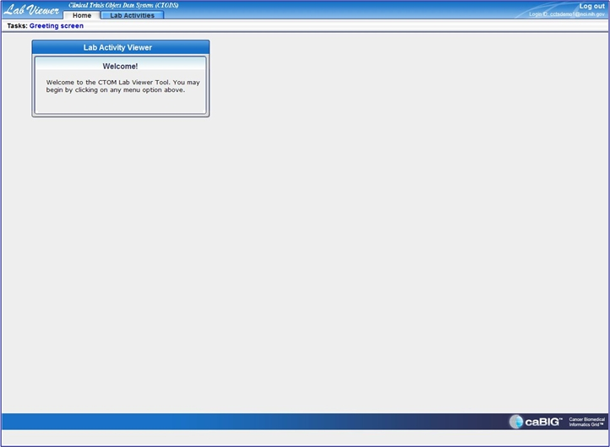

Search for trial(s)

Successful Search Operation
- Select the ‘Lab Activities’ tab.
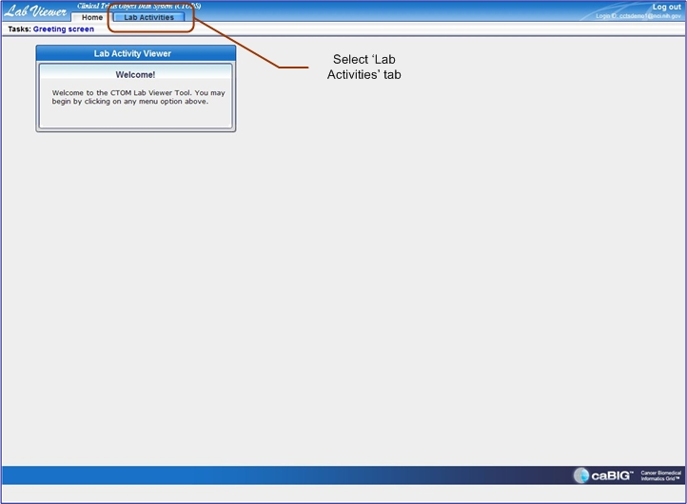
- The ‘Lab Activities’ search page will display.
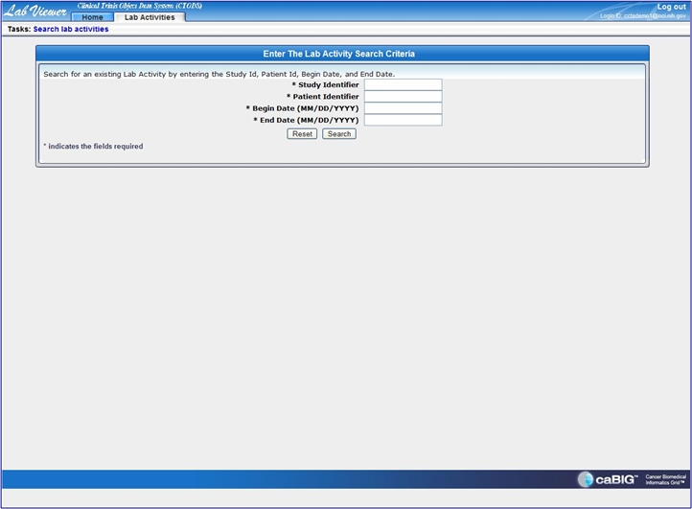
- Enter the desired variables in the search criteria fields (i.e. ‘Study Identifier,’ ‘Patient Identifier,’ ‘Begin Date,’ and ‘End Date’).
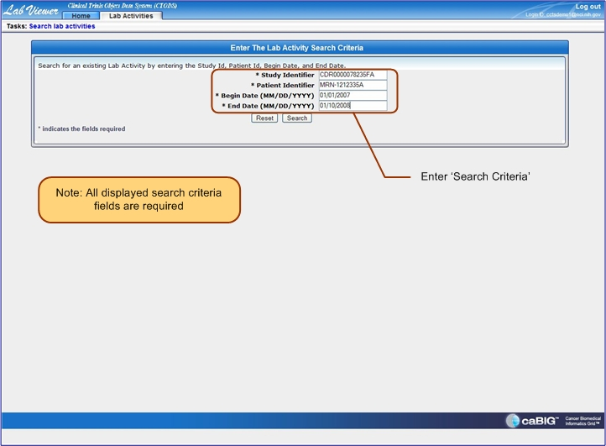
- Select the ‘Search’ button.
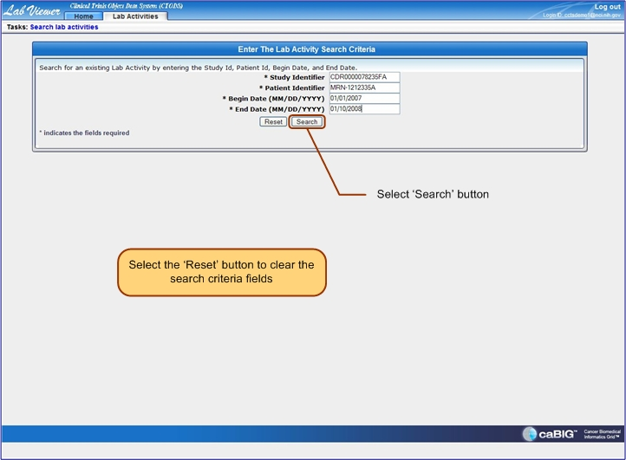
5a. The search results page will display (single result).
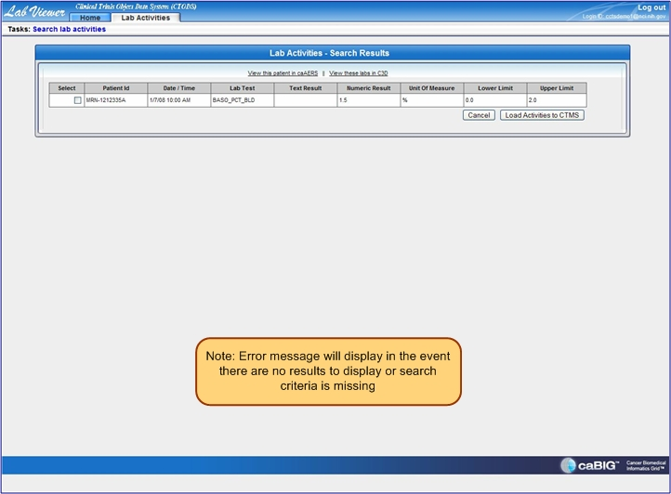
5b. The search results page will display (multiple results).
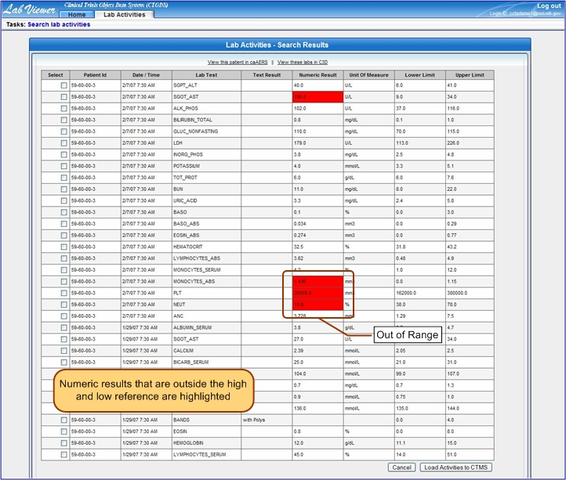

Unsuccessful Search Operation
An error message will display if the entered search criteria are incorrect/missing or there are no results to display.
- An ‘ERROR’ message will display when the ‘Search’ button is selected and the search criteria are incorrect/missing.
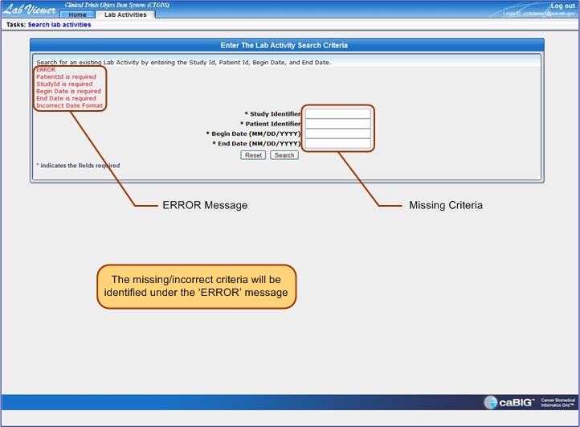
- An ‘ERROR’ message will display when the ‘Search’ button is selected and there are no search results to display.
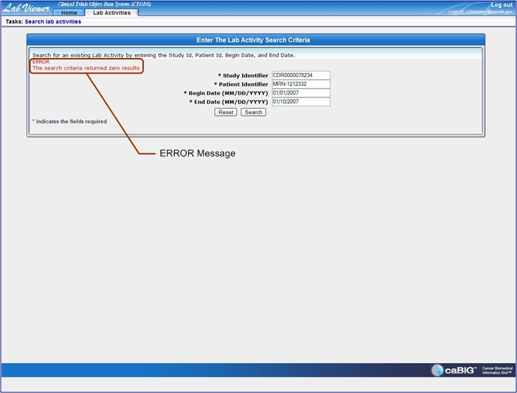

Load results to CTMS
- ‘Check’ the desired search results to export.
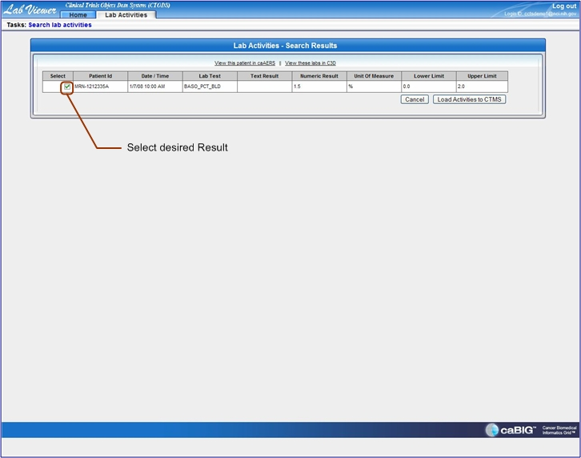
- Select the ‘Load Activities to CTMS’ button.’
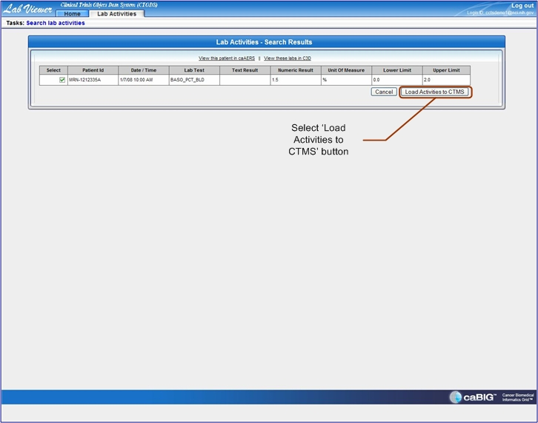
- A ‘Submitted to CTMS Successfully’ message displays on the search results page.
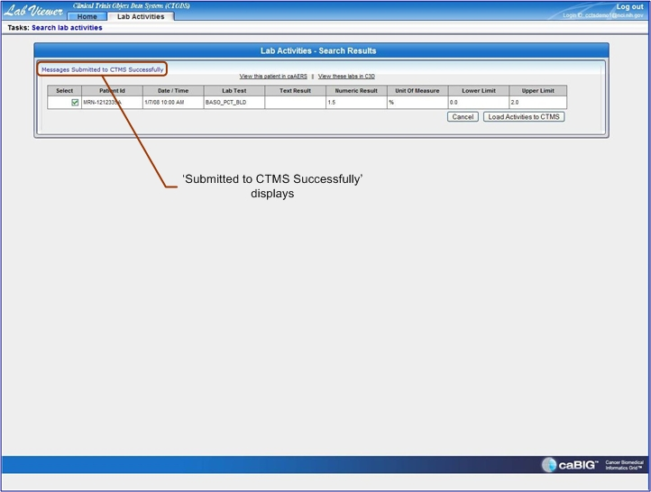

Use Hyperlinks
- Select the ‘View this patient in caAERS’ hyperlink to view addition patient data.
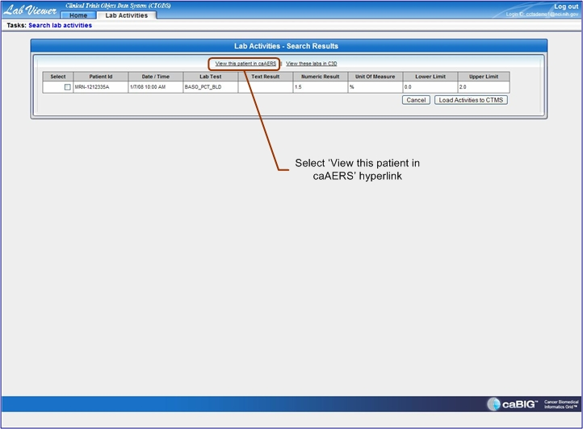
- Select the ‘View these labs in C3D’ hyperlink to view addition laboratory data.
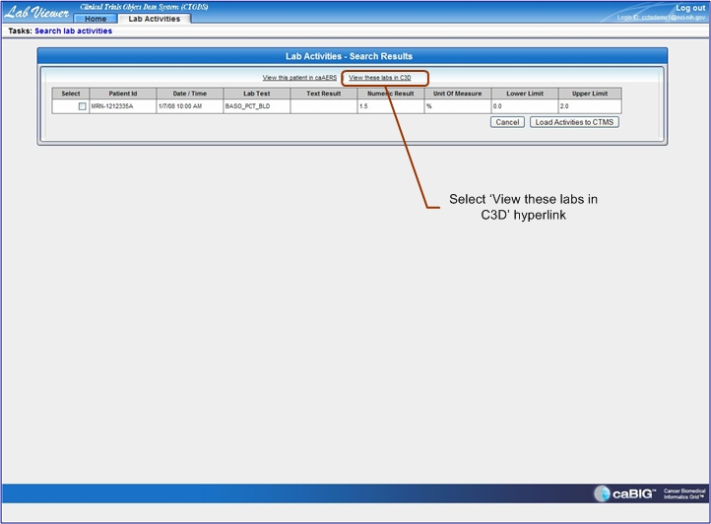

Log Out
- Select the ‘Log Out’ hyperlink to close page.
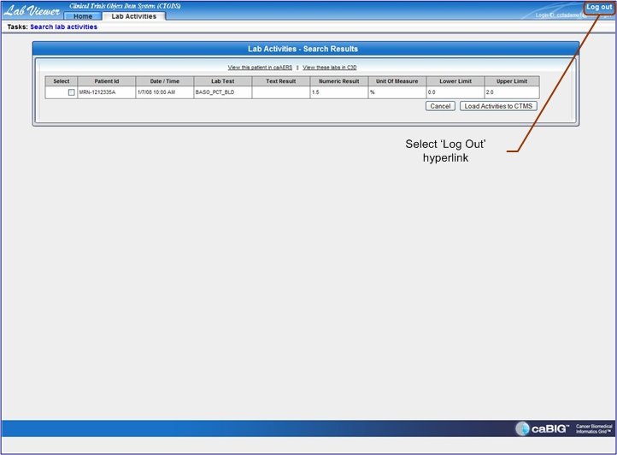
- Close web browser application to terminate CTODS Lab Viewer session.

Hot Linking from caAERS
- When viewing a participant’s labs in caAERS there will be a hot link available to link directly to Lab Viewer.
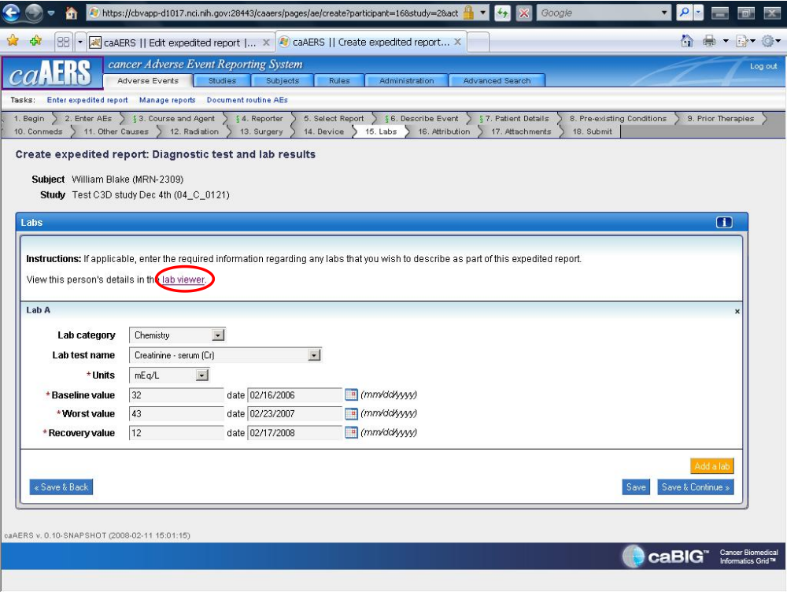
- Selecting this link will open a new browser window to Lab Viewer with the study and patient information pre-populated. The date range will still need to be entered.
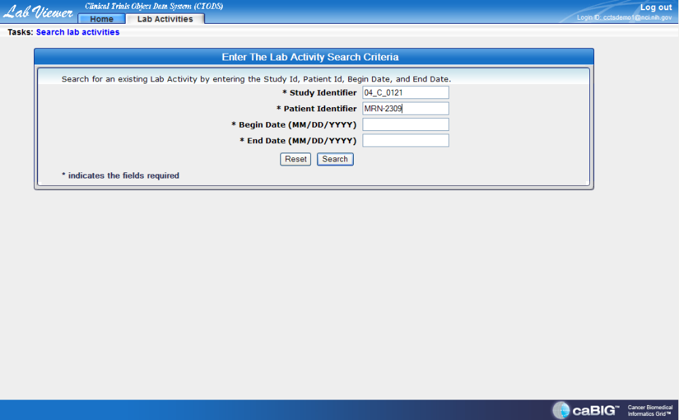

Hot Linking from PSC
- When viewing a patient’s calendar in PSC there will be a hot link available to link directly to Lab Viewer.
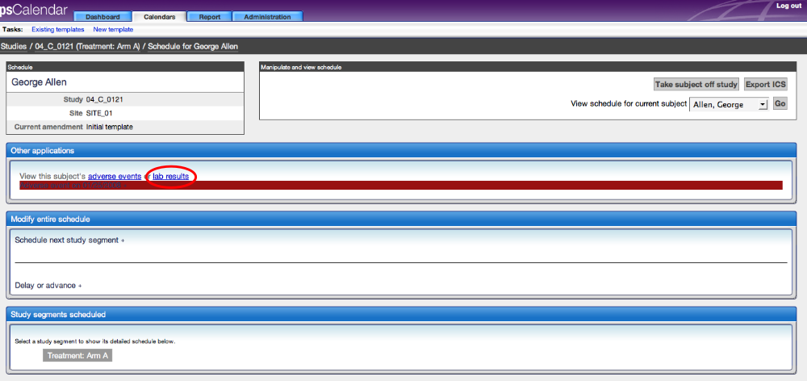
- Selecting this link will open a new browser window to Lab Viewer with the study and patient information pre-populated. The date range will still need to be entered.

